## horizontal line

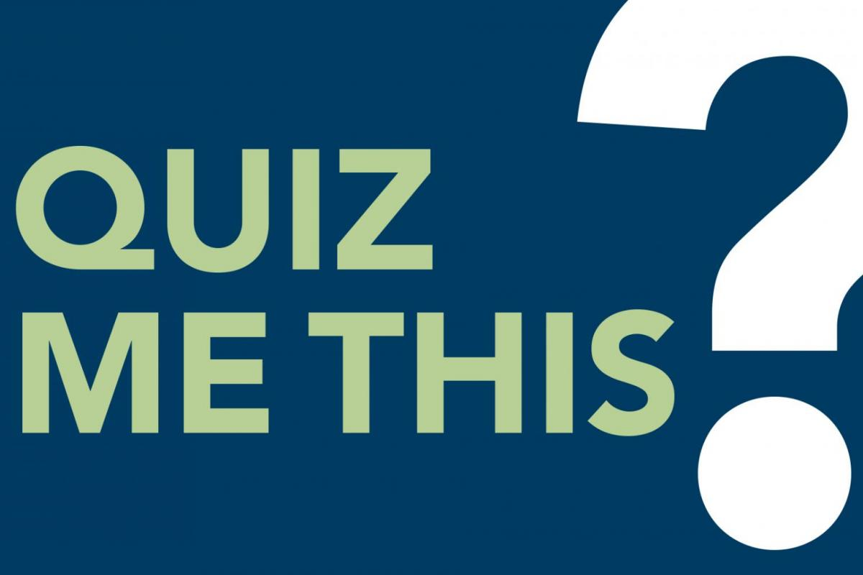

QuizMeThis Website

09.04.2019

**────**

Colton Clary

Greg Yoes-Favrot

Mark Moore

Revature - Fall, 2019

# Overview

We propose website for creating, editing, and making ‘Personality Tests.’ More specifically, tests such as ‘Which Disney Princess Are You?’, etc. Our site will allow users to create tests composed of questions whose answers have varied weight. This will be used to determine a singular result for any set of answers.

# Goals

1. Tests can be created and stored in a cloud database, and scores can be calculated per instance.
2. Users can create, edit, and delete their own tests, as well as tests currently existing.
3. Admins will be able to edit and delete all tests currently existing.

# Specifications

-Angular Front End

-REST API and ASP.NET CORE in Visual Studio

-Postgre SQL Database

-EF Core Code First DB generation

-CI/CD with Azure Pipeline

-build

-test

-Sonar Cloud

-50% coverage

-Deploy to Azure App Service

-Possibly Docker

-Possibly API - Integration

-Authentication with AuthO

-Project Board with Azure Boards